**FLOOD FILL ALGORITHM**

1. Problem: Given a **2D screen**, location of a pixel in the screen and a color, replace color of the given pixel and all adjacent same colored pixels with the given color.

Solution 1: Resursion

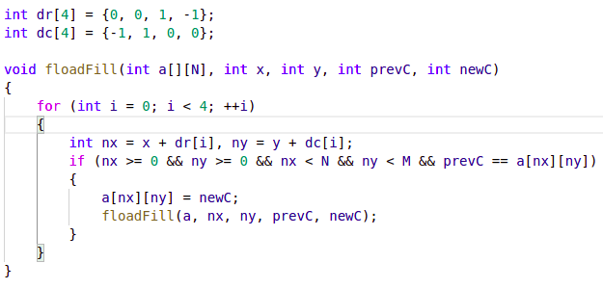

Solution 2: BFS

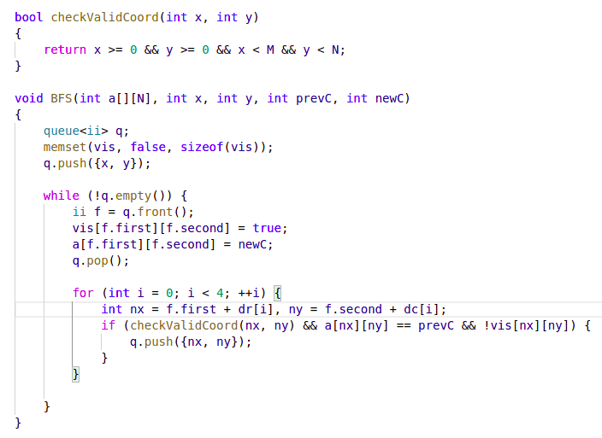

References:

1. https://www.geeksforgeeks.org/flood-fill-algorithm-implement-fill-paint/